**DIGITAL LOGIC DESIGN & COMPUTER ORGANISATION**

**CHAPTER – 1(A) BASIC STRUCTURE OF COMPUTERS**

**Computer types: -**

A computer can be defined as a fast electronic calculating machine that accepts the (data) digitized input information process it as per the list of internally stored instructions and produces the resulting information.

List of instructions are called programs & internal storage is called computer memory.

The different types of computers are

1. **Personal computers: -** This is the most common type found in homes, schools, Business offices etc., It is the most common type of desk top computers with processing and storage units along with various input and output devices.
2. **Note book computers: -** These are compact and portable versions of PC
3. **Work stations: -** These have high resolution input/output (I/O) graphics capability, but with same dimensions as that of desktop computer. These are used in engineering applications of interactive design work.
4. **Enterprise systems: -** These are used for business data processing in medium to large corporations that require much more computing power and storage capacity than work stations. Internet associated with servers have become a dominant worldwide source of all types of information.
5. **Super computers: -** These are used for large scale numerical calculations required in the applications like weather forecasting etc.,

# Functional unit: -

A computer consists of five functionally independent main parts input, memory, arithmetic logic unit (ALU), output and control unit.

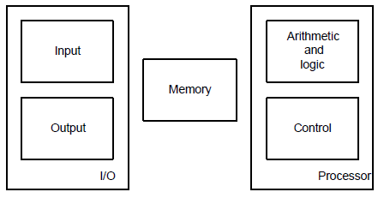

Fig: Basic functional units of a computer

Input device accepts the coded information as source program i.e. high level language. This is either stored in the memory or immediately used by the processor to perform the desired operations. The program stored in the memory determines the processing steps. Basically the computer converts one source program to an object program. i.e. into machine language.

Finally the results are sent to the outside world through output device. All of these actions are coordinated by the control unit.

# Input unit: -

The source program/high level language program/coded information/simply data is fed to a computer through input devices keyboard is a most common type. Whenever a key is pressed, one corresponding word or number is translated into its equivalent binary code over a cable & fed either to memory or processor.

Joysticks, trackballs, mouse, scanners etc are other input devices.

# Memory unit: -

Its function into store programs and data. It is basically to two types

# Primary memory

* 1. **Secondary memory**

**1. Primary memory: -** Is the one exclusively associated with the processor and operates at the electronics speeds programs must be stored in this memory while they are being executed. The memory contains a large number of semiconductors storage cells. Each capable of storing one bit of information. These are processed in a group of fixed site called word.

To provide easy access to a word in memory, a distinct address is associated with each word location. **Addresses are** numbers that identify memory location.

Number of bits in each word is called word length of the computer. Programs must reside in the memory during execution. Instructions and data can be written into the memory or read out under the control of processor.

Memory in which any location can be reached in a short and fixed amount of time after specifying its address is called random-access memory (RAM).

The time required to access one word in called memory access time. Memory which is only readable by the user and contents of which can’t be altered is called read only memory (ROM) it contains operating system.

Caches are the small fast RAM units, which are coupled with the processor and are often contained on the same IC chip to achieve high performance. Although primary storage is essential it tends to be expensive.

**2 Secondary memory: -** Is used where large amounts of data & programs have to be stored, particularly information that is accessed infrequently.

**Examples: -** Magnetic disks & tapes, optical disks (i.e., CD-ROM’s), floppies etc.,

# Arithmetic logic unit (ALU):-

Most of the computer operators are executed in ALU of the processor like addition, subtraction, division, multiplication, etc. the operands are brought into the ALU from memory and stored in high speed storage elements called register. Then according to the instructions the operation is performed in the required sequence.

The control and the ALU are many times faster than other devices connected to a computer system. This enables a single processor to control a number of external devices such as key boards, displays, magnetic and optical disks, sensors and other mechanical controllers.

# Output unit:-

These actually are the counterparts of input unit. Its basic function is to send the processed results to the outside world.

**Examples:-** Printer, speakers, monitor etc.

# Control unit:-

It effectively is the nerve center that sends signals to other units and senses their states. The actual timing signals that govern the transfer of data between input unit, processor, memory and output unit are generated by the control unit.

# Basic operational concepts: -

To perform a given task an appropriate program consisting of a list of instructions is stored in the memory. Individual instructions are brought from the memory into the processor, which executes the specified operations. Data to be stored are also stored in the memory.

**Examples: -** Add LOCA, R0

This instruction adds the operand at memory location LOCA, to operand in

register R0 & places the sum into register. This instruction requires the performance of several steps,

1. First the instruction is fetched from the memory into the processor.
2. The operand at LOCA is fetched and added to the contents of R0
3. Finally the resulting sum is stored in the register R0

The preceding add instruction combines a memory access operation with an ALU Operations. In some other type of computers, these two types of operations are performed by separate instructions for performance reasons.

Load LOCA, R1 Add R1, R0

Transfers between the memory and the processor are started by sending the address of the memory location to be accessed to the memory unit and issuing the appropriate control signals. The data are then transferred to or from the memory.

|  |  |
| --- | --- |
| **MAR** | **MDR** |

|  |  |  |  |  |
| --- | --- | --- | --- | --- |
| **PC** |  | R0 |  |  |
|  |  | R1 |  |  |
|  |  | … |  | **ALU** |
|  |  | … |
| **IR** |  | … |  |  |
|  |  | … |  |  |
|  |  | Rn-1 |  |  |
|  |  | n- GPRs |  |  |

Fig b : Connections between the processor and the memory

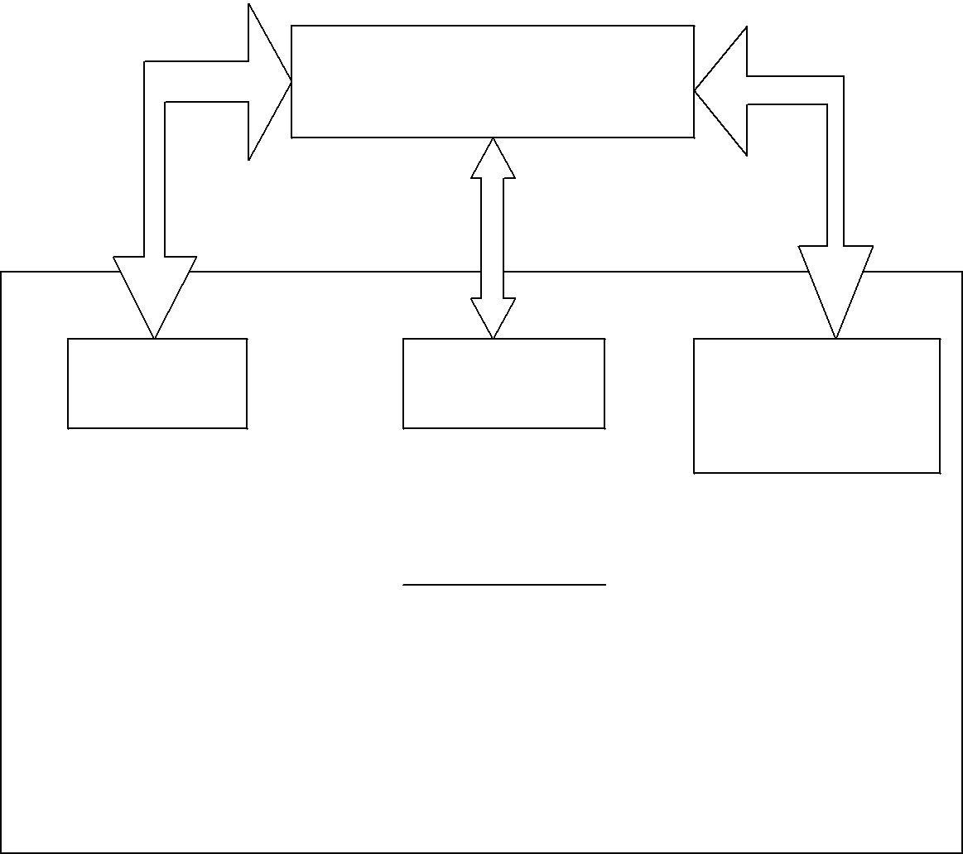

**MEMORY**

**CONTROL**

The fig shows how memory & the processor can be connected. In addition to the ALU & the control circuitry, the processor contains a number of registers used for several different purposes.

**The instruction register (IR):-** Holds the instructions that is currently being executed. Its output is available for the control circuits which generates the timing signals that control the various processing elements in one execution of instruction.

# The program counter PC:-

This is another specialized register that keeps track of execution of a program. It contains the memory address of the next instruction to be fetched and executed.

Besides IR and PC, there are n-general purpose registers R0 through Rn-1

1. The other two registers which facilitate communication with memory are: -
   1. **MAR – (Memory Address Register):-** It holds the address of the location to be

accessed.

* 1. **MDR – (Memory Data Register):-** It contains the data to be written into or read out of the address location.

# Operating steps are

1. Programs reside in the memory & usually get these through the I/P unit.
2. Execution of the program starts when the PC is set to point at the first instruction of the program.
3. Contents of PC are transferred to MAR and a Read Control Signal is sent to the memory.
4. After the time required to access the memory elapses, the address word is read out of the memory and loaded into the MDR.
5. Now contents of MDR are transferred to the IR & now the instruction is ready to be decoded and executed.
6. If the instruction involves an operation by the ALU, it is necessary to obtain the required operands.
7. An operand in the memory is fetched by sending its address to MAR & Initiating a read cycle.
8. When the operand has been read from the memory to the MDR, it is transferred from MDR to the ALU.
9. After one or two such repeated cycles, the ALU can perform the desired operation.
10. If the result of this operation is to be stored in the memory, the result is sent to MDR.
11. Address of location where the result is stored is sent to MAR & a write cycle is initiated.
12. The contents of PC are incremented so that PC points to the next instruction that is to be executed.

Normal execution of a program may be preempted (temporarily interrupted) if some devices require urgent servicing, to do this one device raises an Interrupt signal.

An interrupt is a request signal from an I/O device for service by the processor. The processor provides the requested service by executing an appropriate interrupt service routine.

The Diversion may change the internal stage of the processor its state must be saved in the memory location before interruption. When the interrupt-routine service is completed the state of the processor is restored so that the interrupted program may continue.

# Bus structure: -

The simplest and most common way of interconnecting various parts of the computer.

To achieve a reasonable speed of operation, a computer must be organized so that all its units can handle one full word of data at a given time.

A group of lines that serve as a connecting port for several devices is called a

bus.

In addition to the lines that carry the data, the bus must have lines for address and control purpose.

Simplest way to interconnect is to use the single bus as shown

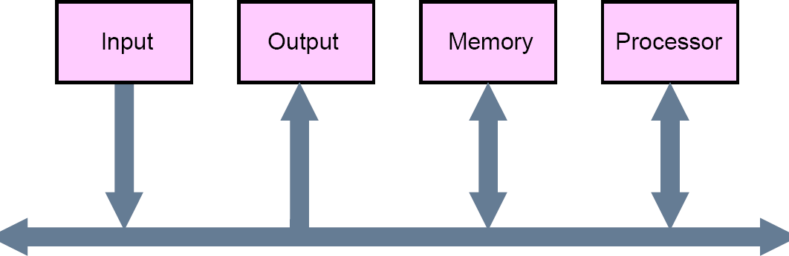

Fig c: Single bus structure

Since the bus can be used for only one transfer at a time, only two units can actively use the bus at any given time. Bus control lines are used to arbitrate multiple requests for use of one bus.

Single bus structure is

* Low cost
* Very flexible for attaching peripheral devices

Multiple bus structure certainly increases the performance but also increases the cost significantly.

All the interconnected devices are not of same speed & time leads to a bit of a problem. This is solved by using cache registers (i.e., buffer registers). These buffers are electronic registers of small capacity when compared to the main memory but of comparable speed.

The instructions from the processor at once are loaded into these buffers and then the complete transfer of data at a fast rate will take place.

# Performance: -

The most important measure of the performance of a computer is how quickly it can execute programs. The speed with which a computer executes program is affected by the design of its hardware. For best performance, it is necessary to design the compiles, the machine instruction set, and the hardware in a coordinated way.

The total time required to execute the program is elapsed time is a measure of the performance of the entire computer system. It is affected by the speed of the processor, the disk and the printer. The time needed to execute a instruction is called the processor time.

# Processor clock: -

Processor circuits are controlled by a timing signal called clock. The clock designer the regular time intervals called clock cycles. To execute a machine instruction the processor divides the action to be performed into a sequence of basic steps that each step can be completed in one clock cycle. The length P of one clock cycle is an important parameter that affects the processor performance.

Processor used in today’s personal computer and work station have a clock rates

that range from a few hundred million to over a billion cycles per second.

# Basic performance equation: -

We now focus our attention on the processor time component of the total elapsed time. Let ‘T’ be the processor time required to execute a program that has been prepared in some high-level language. The compiler generates a machine language object program that corresponds to the source program. Assume that complete execution of the program requires the execution of N machine cycle language instructions. The number N is the actual number of instruction execution and is not necessarily equal to the number of machine cycle instructions in the object program. Some instruction may be executed more than once, which in the case for instructions inside a program loop others may not be executed all, depending on the input data used.

Suppose that the average number of basic steps needed to execute one machine cycle instruction is S, where each basic step is completed in one clock cycle. If clock rate is ‘R’ cycles per second, the program execution time is given by

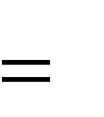*N*



*S*

*T*

*R*

this is often referred to as the basic performance equation.

We must emphasize that N, S & R are not independent parameters changing one may affect another. Introducing a new feature in the design of a processor will lead to improved performance only if the overall result is to reduce the value of T.

# Pipelining and super scalar operation: -

We assume that instructions are executed one after the other. Hence the value of S is the total number of basic steps, or clock cycles, required to execute one instruction.

A substantial improvement in performance can be achieved by overlapping the execution of successive instructions using a technique called pipelining.

Consider Add R1 R2 R3

This adds the contents of R1 & R2 and places the sum into R3.

The contents of R1 & R2 are first transferred to the inputs of ALU. After the

addition operation is performed, the sum is transferred to R3. The processor can read the next instruction from the memory, while the addition operation is being performed. Then of that instruction also uses, the ALU, its operand can be transferred to the ALU inputs at

the same time that the add instructions is being transferred to R3.

In the ideal case if all instructions are overlapped to the maximum degree possible the execution proceeds at the rate of one instruction completed in each clock cycle. Individual instructions still require several clock cycles to complete. But for the purpose of computing T, effective value of S is 1.

A higher degree of concurrency can be achieved if multiple instructions pipelines are implemented in the processor. This means that multiple functional units are used creating parallel paths through which different instructions can be executed in parallel with such an arrangement, it becomes possible to start the execution of several instructions in every clock cycle. This mode of operation is called superscalar execution. If it can be sustained for a long time during program execution the effective value of S can be reduced to less than one. But the parallel execution must preserve logical correctness of programs, that is the results produced must be same as those produced by the serial execution of program instructions. Now a days may processor are designed in this manner.

**Clock rate:-** These are two possibilities for increasing the clock rate ‘R’.

1. Improving the IC technology makes logical circuit faster, which reduces the time of execution of basic steps. This allows the clock period P, to be reduced and the clock rate R to be increased.
2. Reducing the amount of processing done in one basic step also makes it possible to reduce the clock period P. however if the actions that have to be performed by an instructions remain the same, the number of basic steps needed may increase.

Increase in the value ‘R’ that are entirely caused by improvements in IC technology affects all aspects of the processor’s operation equally with the exception of the time it takes to access the main memory. In the presence of cache the percentage of accesses to the main memory is small. Hence much of the performance gain excepted from the use of faster technology can be realized.

# Performance measurements:-

It is very important to be able to access the performance of a computer, comp designers use performance estimates to evaluate the effectiveness of new features.

The previous argument suggests that the performance of a computer is given by the execution time T, for the program of interest.

Inspite of the performance equation being so simple, the evaluation of ‘T’ is highly complex. Moreover the parameters like the clock speed and various architectural features are not reliable indicators of the expected performance.

Hence measurement of computer performance using bench mark programs is done to make comparisons possible, standardized programs must be used.

The performance measure is the time taken by the computer to execute a given bench mark. Initially some attempts were made to create artificial programs that could be used as bench mark programs. But synthetic programs do not properly predict the performance obtained when real application programs are run.

A non profit organization called SPEC- system performance evaluation corporation selects and publishes bench marks.

The program selected range from game playing, compiler, and data base applications to numerically intensive programs in astrophysics and quantum chemistry. In each case, the program is compiled under test, and the running time on a real computer is measured. The same program is also compiled and run on one computer selected as reference.

The ‘SPEC’ rating is computed as follows.

SPEC rating =

Running time on the reference computer Running time on the computer under test

# Multiprocessor & microprocessors:-

* Large computers that contain a number of processor units are called multiprocessor system.
* These systems either execute a number of different application tasks in parallel or execute subtasks of a single large task in parallel.
* All processors usually have access to all memory locations in such system & hence they are called shared memory multiprocessor systems.
* The high performance of these systems comes with much increased complexity and cost.
* In contrast to multiprocessor systems, it is also possible to use an interconnected group of complete computers to achieve high total computational power. These computers normally have access to their own memory units when the tasks they are executing need to communicate data they do so by exchanging messages over a communication network. This properly distinguishes them from shared memory multiprocessors, leading to name message-passing multi computer.